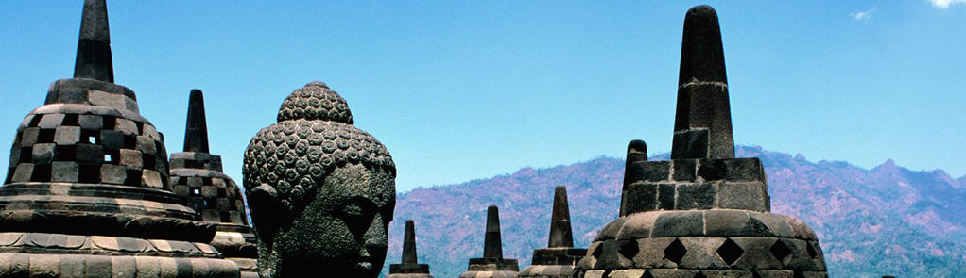

Explore Jakarta with our attractive Holiday Packages from Mihin Lanka, where with our low prices and generous baggage allowance, Jakarta has never been more affordable

2 Nights/ 3 Days | only Rs 53,300 per person
3 Nights / 4 Days | only Rs 57,100 per person

Package includes
- Return Air Ticket inclusive of all applicable taxes
- Indonesia Visa Charges
- Accommodation at a star class hotel on a twin / double sharing basis
- Daily Breakfast
- Return Airport Transfers

For more information and details please contact us on 0112002255 or 0117800321

